A New Student Assessment Method Using Fuzzy Logic System
Abdul Aziz, Md. Asaf-uddowla Golap and M. M. A. Hashem
Department of Computer Science and Engineering
Khulna Univeresity of Engineering & Technology, Khulna-9203, Bangladesh
abdulaziz@cse.kuet.ac.bd, asaf.golap@kuet.ac.bd, hashem@cse.kuet.ac.bd

Abstract— For evaluating student’s performance, the existing methods are not so much fair and satisfiable. The ranges of marks used for grading here are sometimes blessing and sometimes not. A method is proposed to evaluate performance based on Fuzzy Inference System (FIS). This system considers the student’s continuous assessment which includes the attendances, total times he/she is spent in class and marks obtained in class test. This method increases the fairness and excellency of a student’s assessment than existing methods. In existing FIS for grading the continuous assessment of student is not fuzzified where only the final exam papers mark is fuzzified. But, the proposed system fuzzified both the continuous assessment and exam papers mark which actually increase more precise justification of student performances.
Keywords— Fuzzy Inference System, Fuzzy Logic, Expert System, Membership Function, Fuzzification, Defuzzification, Continuous Assessment, Student Performance Evaluation.

Introduction
Student performance evaluation is one of the most important tasks in an educational institute. Proper evaluation method ensures fair evaluation what is highly desired and student grade should comply with performance. Student’s performance depends on various factor such as attendance, class test, final exam etc. Considering, these factors final grade is calculated. In many universities only, number of class simply is considered for evaluating attendance. However, both number of class as well as time spent on class should be considered in the evaluation process, as class size large in most of universities in developing countries such as Bangladesh and student sometimes do not attend the class full time. For this purpose, a specialized hardware is used which outputs number of class and time spent on the class.
Examinations are conducted in most of the universities, college and institutes of a subject in a subjective manner. In these examinations’ students ask to write either short or detail answer which is indicated in the exam paper and depending on allotted time of that specific question. Usually, to solve 100 marks exam paper maximum 3 to 4 hours is given as a whole but time is not specified for each question, overall time management depends on students. Finally, performance is computed from their examination, class test, attendance etc. and each of these sections has a predefined weight.
Student educational performance is measured based on the results of examinations and usually expressed numerically or by later grades [1]. Conventional method compares student performance with predefined measurement criteria. Evaluation and measurement are vital parts of the educational process. Various methods are using for evaluating student performance.

Related Work
In 1965, fuzzy set theory was introduced by Lotfi A. Zadeh [2]. In recent years, it has been used extensively in a number of research fields including educational system to remove vagueness that conventional methods unable to solve properly. Echauz and Vachtsevanos in [3] proposed a system using fuzzy set theory for converting conventional result into later-grades. Law in [4] developed a fuzzy educational grading system structure model and proposed an algorithm to aggregate various test scores to generate a final single score of a student. It also discussed the method to build the membership functions of several linguistic values with different weights. Bai and Chen in [5] proposed a scheme to generate membership function of fuzzy rules automatically. Then this membership function used in fuzzy logic to obtain the marks of a student. It devised an unbiased and smooth scheme for evaluating students answer scripts. Then Biswas offered a method in [6] to evaluate student performance using fuzzy logic and fuzzy inference system. It took too much time to predict performance and there was chance to assign same grade for to different fuzzy marks. Later, Chen and Lee in [7] present a method which remove the limitation of the previous scheme by Biswas. Their method is faster enough and do not need any complicate matching operations.
Wilson et. al in [8] proposed a method using fuzzy set theory and genetic algorithm. Ramjeet and Vijendran in [9] consider student performance evaluation problem as a clustering problem where clusters (classes) are generated from student talent level and no. of cluster should be less than or equal to the predefined capacity. In [10] Arya et. al designed a dynamic model mainly for engineering students which take final exam marks as well as lab and project performance into account to devise final grade applying fuzzy model. Shilpa in [11] used fuzzy logic to measure a student performance considering vagueness of question paper along with accuracy rate, relative importance and complexity. Reference [12] represents a method by James using fuzzy expert system to evaluate student writing samples with high level of accuracy comparable to the best teacher graders. Ibrahim in [13] proposed an easy, transparent, fair, automatic method taking the difficulty, the importance and the complexity of questions in account applying fuzzy inference system to provide student learning achievements. Wang and Chen in [14] presented a method for evaluating students’ answer scripts using fuzzy numbers associated with degrees of confidence of the evaluator. Bardul proposed a method in [15] to evaluate the student’s performance as an individual and as a group. This focus of this method is to evaluate student’s answer sheet and group performance assessment of a student.

Basic Fuzzy Logic
Fuzzy logic was introduced by Prof. Lotif Zadeh to handle imprecision, vagueness and uncertainty of data. On the basis of working procedure, a fuzzy controller is similar to a traditional system. It takes inputs then carry out calculations and finally provide an output value. Fig. 1 illustrates the basic structure of a fuzzy system. Fuzzification is a process of converting crisp input values into fuzzy values using fuzzy member functions. Defuzzification is the reverse process of fuzzification which converts this latter output into crisp values again.

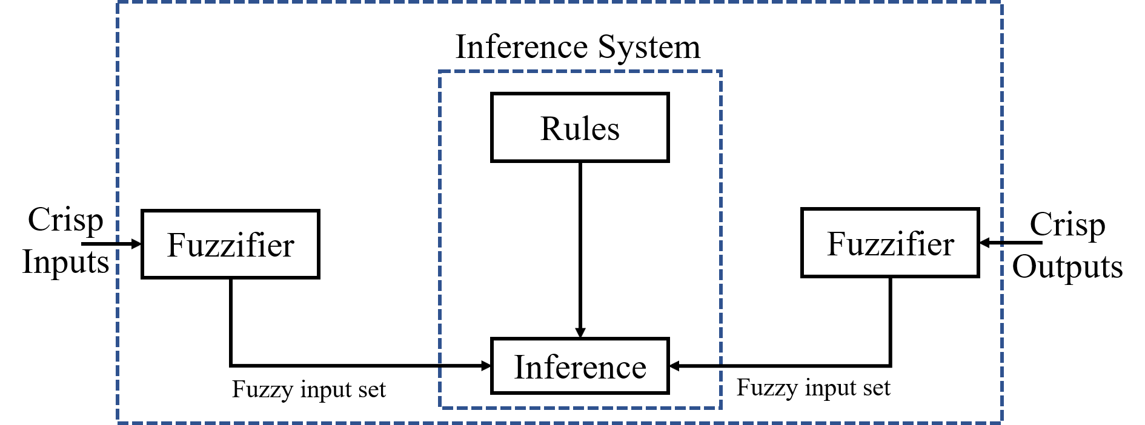

Fig. 1 Basic Fuzzy System

Motivation
Existing grading system is strict. This grading system has some predefined range of marks defined by University Grants Commission (UGC) of Bangladesh and a grade is awarded (e.g. A+, A, A-, B+, B, B-, C+, C, D, F etc.) equivalent to an integer interval such as 80-100 (A+), 75-(<80) (A), 70-(<75) (A-), 65-(<70)(B+), 60-(<65) (B), 55-(<60) (B-), 50-(<55) (C+), 45-(<50) (C), 40-(<45) (D), <40 (F) etc. The mark is simply obtained from different sections as a mean (class test, attendance, final exam etc). In this method same grade is awarded for a range of marks, for example if a student gets 80 and another student gets 100 percent of mark both of them will get the same grade A+, it is not fair. Therefore, an evaluation system is demanded which will provide fairness, transparency, objectivity, logical reasoning, and easy computer implementation.
Unlike existing grading system in fuzzy logic system every single mark is considered for calculating final grade as every mark has a degree of membership value in membership function. Although performance assessment process using fuzzy logic is intricate, it is flexible, whereas traditional grading system stick to fixed mathematical calculation.

Contibution
This paper proposes a new method to evaluate student performance using fuzzy logic and fuzzy inference system. We summarize our contributions in this paper as follows:
- We consider number of classes as well as total time spent on the class. In credit system there is a direct relation between class time and credit. So, we have considered the total time spent on class for assessment.
- Continuous assessment (attendance, time spent on class and Class Test) and Final examination both are vital for measuring student performance. Our system considers both of these for assessing student’s performance.
- Comparison between existing method and our proposed method has been done.

Organisation
This research paper forms as: section II which discusses the overall methodology how does the system work. Section III contains the performance analysis of students and results are compared with traditional method. In section IV, the conclusion of the research work is added.

Methodology
- Proposed System for Evaluating Students Performance
In Bangladeshi University, for evaluating student’s performance in each subject the mark is divided into two parts. So, our system consists of two parts. First part is student’s continuous assessment student which includes class test, attendance and total time spent in class. Second part is semester final examination’s where exam paper is separated into two parts named Part-A and Part-B. The mark distribution for Part-A and Part-B is equal. The overall architecture of the proposed system is shown in Fig. 2.
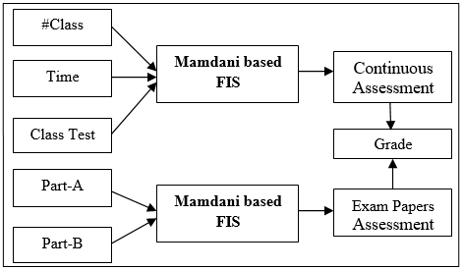
Fig. 2 Proposed System Architecture

  - Students Continuous Assessment System
In existing Student’s Continuous Assessment System, the total no. of class and Class Test (CT) is considered which is not very much fair. But in our proposed system the total amount of time a student spent on class room is also considered which makes the assessment process more fair than existing system.

    - Fuzzification of Students Continuous Assessment
In this part, we have three linguistic input variables called Total number of class (#Class) and Total time spent in class (Time) and Class_Test. The linguistic values and interval for the variables are shown in the Table I, Table II and Table III.
Table I: Linguistic Values and Intervals for Input variable “#Class”
Linguistic Values | Intervals
Few (F) | (0, 0, 0.20, 0.30)
Average (A) | (0.20, 0.30, 0.45, 0.55)
High (H) | (0.45, 0.55, 0.70, 0.80)
Very High (VH) | (0.70, 0.80, 1, 1)

Table II: Linguistic Values and Intervals for Input variable “Time”
Linguistic Values | Intervals
Low (L) | (0,0, 0.20, 0.40)
Average (AV) | (0.20, 0.40, 0.60, 0.80)
Large (LG) | (0.60, 0.80, 1, 1)

Table III: Linguistic Values and Intervals for Input variable “Class_Test”
Linguistic Values | Intervals
Very Low (VL) | (0,0,0.15,0.25)
Low (L) | (0.15, 0.25, 0.35, 0.45)
Average (A) | (0.35, 0.45, 0.55, 0.65)
High (H) | (0.55, 0.65, 0.75, 0.85)
Very High (VH) | (0.75, 0.85,1,1)

The trapezoidal membership function is used for all the input variables “#Class”, “Time” and “Class_Test” as shown in Fig. 3, Fig. 4 and Fig. 5. The output variable for this part is assessment whose linguistic value is as same as input variable Class_Test shown in Table III and Fig. 5.

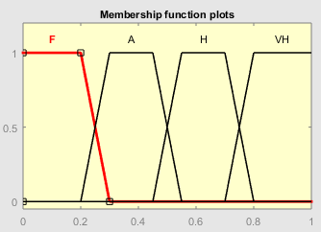
Fig. 3 Membership Function for #Class

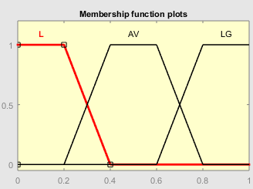
Fig. 4 Membership Function for Time
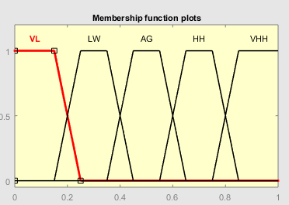
Fig. 5 Membership Function for Class_Test
    - Rules Evaluation for Assessment
The Fuzzy inference system uses the “IF Then Else” rules. For each of the input variables value the rules generated as follows.
1. If (#Class is F) and (Time is L) and (Class_Test is VL) then (Assessment is VL) (1)
2. If (#Class is F) and (Time is L) and (Class_Test is LW) then (Assessment is VL) (1)
3. If (#Class is F) and (Time is L) and (Class_Test is AG) then (Assessment is VL) (1)
4. If (#Class is F) and (Time is L) and (Class_Test is HH) then (Assessment is LW) (1)
5. If (#Class is F) and (Time is L) and (Class_Test is VHH) then (Assessment is LW) (1)
………………………………………………………………………...
58. If (#Class is VH) and (Time is LG) and (Class_Test is AG) then (Assessment is VH) (1)
59. If (#Class is VH) and (Time is LG) and (Class_Test is HH) then (Assessment is VHH) (1)
60. If (#Class is VH) and (Time is LG) and (Class_Test is VHH) then (Assessment is VHH) (1)
The degree of membership value is generated by the trapezoidal membership function for each of the linguistic value of an input variable. In Fuzzy rules there are more than one value exists. So, a single value is need to choose. There are several ways to choose it. One is MIN rule and another one is MAX rule. The MIN rules select the minimum values among the degree of membership values which are ANDed by each other’s. The MAX rules select the maximum values among the degree of membership values which are ORed by each other’s.

    - Determining the Assessment Score
There are many others ways to calculate the final assessment score which is called defuzzification. In this paper we have used center of gravitation (COG) method or center of area calculating method.

  - Students Exam Papers Assessment System
    - Fuzzification of Student’s Exam Papers
The answer script or the Exam paper is divided into two parts as Part-A and Part-B. So, in this part we have two linguistic input variables Part-A and Part-B. The linguistic value and interval for both of these variables are shown in Table IV.
Table IV: Input Variable and it's Interval For “Part-A” and “Part-B”
Linguistic Value | Interval
Very Low (VL) | (0,0, 0.02, 0.18)
Low (L) | (0.02,0.18,0.22,0.38)
Average(A) | (0.22,0.38,0.42,0.58)
High (H) | (0.42,0.58,0.62,0.78)
Very High (VH) | (0.62,0.78,0.82,0.98)
Very Very High (VHH) | (0.82,0.98,1,1)

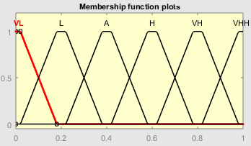
Fig. 6 Membership Function for Part-A and Part-B

Assessment is the output variable in this part whose linguistic variable and interval is same as input variable Part-A and Part-B as shown in Table IV and Fig. 6.

    - Rules for Performance of Two Variable
The same “IF Then Else” rules are used to measure the performance of student.
1. If (Part-A is VL) and (Part-B is VL) then (Performance is VL)
2. If (Part-A is VL) and (Part-B is L) then (Assessment is VL)
3. If (Part-A is VL) and (Part-B is A) then (Assessment is L)
4. If (Part-A is VL) and (Part-B is H) then (Assessment is L)
5. If (Part-A is VL) and (Part-B is VH) then (Assessment is A)
………………………………………………………………………
31. If (Part-A is VHH) and (Part-B is VL) then (Assessment is A)
32. If (Part-A is VHH) and (Part-B is L) then (Assessment is H)
33. If (Part-A is VHH) and (Part-B is A) then (Assessment is VH)
34. If (Part-A is VHH) and (Part-B is H) then (Assessment is VH)
35. If (Part-A is VHH) and (Part-B is VH) then (Assessment is VHH)
36. If (Part-A is VHH) and (Part-B is VHH) then (Assessment is VHH)

The MIN and MAX rules are also used in this part for selecting only one value from several values.

    - Determining the Assessment Result
Same method (COG) is used for determining exam paper Assessment for a student which is used for determining the assessment score.

Performance Analysis

Dataset
Actually, our system is divided into two parts for evaluating student’s performance for considering the student’s continuous assessment related data and final exam paper data. In continuous assessment data, there are three fields named number of class, time spent in class and class test. For exam paper, also considered two fields named marks of exam papers Part-A and Part-B. The benchmark dataset is collected from Khulna University of Engineering & Technology (KUET), Khulna-9203, Bangladesh.

Result Analysis
For evaluating overall performance, we have used Mamdani type fuzzy inference engine which we have described briefly in methodology section (Section II). The performance of 15 students based on their benchmark dataset collected from KUET is shown in Table V. Total number of class is considered 39 for each course and length of every class lecture is 50 minutes. So, total 50x39 = 1950 minutes (Time) a student can be spent in class. The final grade of an individual subject is calculated considering 30% marks in continuous assessment and 70% marks in exam papers evaluation. Then, the total marks obtained from continuous assessment and exam papers assessment is added to get the grade.
In Fig. 7 shows the assessment score is 0.9 for a student whose attendance is 94.9%, time spent in class is 96.8%. and class test is 96.67%. Similarly, Fig. 8 shows the Assessment value is 0.8 for a student whose exam paper marks are 78.1% and 67.6% in Part-A and Part-B respectively.
Table V: Assessment of Student by Proposed Method
SI No. | # Class | Time Spent on Class (Minute) | Class Test | Continuous Assessment | Part-A Mark | Part-B Mark | Exam Paper Assessment | Grade
1 | 37 | 1790 | 58 | 0.900 | 82 | 71 | 0.800 | A+
2 | 28 | 660 | 60 | 0.858 | 52 | 67 | 0.606 | B+
3 | 26 | 1000 | 40 | 0.689 | 59 | 54 | 0.512 | B-
4 | 25 | 1200 | 28 | 0.326 | 56 | 55 | 0.533 | C
5 | 32 | 1400 | 10 | 0.338 | 49 | 76 | 0.627 | C+
6 | 20 | 952 | 35 | 0.494 | 73 | 69 | 0.695 | B
7 | 29 | 1400 | 18 | 0.404 | 58 | 57 | 0.517 | C
8 | 34 | 1400 | 55 | 0.900 | 62 | 63 | 0.600 | B+
9 | 16 | 672 | 44 | 0.500 | 64 | 55 | 0.600 | B-
10 | 15 | 500 | 33 | 0.300 | 48 | 57 | 0.547 | C
11 | 12 | 444 | 23 | 0.176 | 73 | 66 | 0.695 | C+
12 | 36 | 1303 | 39 | 0.763 | 69 | 73 | 0.645 | B+
13 | 08 | 350 | 29 | 0.300 | 42 | 69 | 0.600 | C+
14 | 35 | 1700 | 51 | 0.900 | 21 | 44 | 0.215 | D
15 | 20 | 1144 | 10 | 0.151 | 32 | 76 | 0.505 | F

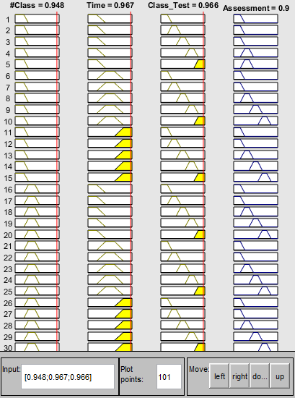

Fig. 7 Assessment Value for Student 1 Who was Presented 37 Class, Spent 1890 Minutes in Class and Got 58 in Class Test.

Comparison with Existing Method
The comparing study between the existing system and the proposed fuzzy assessment system for the same 15 student’s dataset is shown in Table VI. It shows, in the existing system the assessment score is always 0.00 for the students whose attendance is less than 60%.
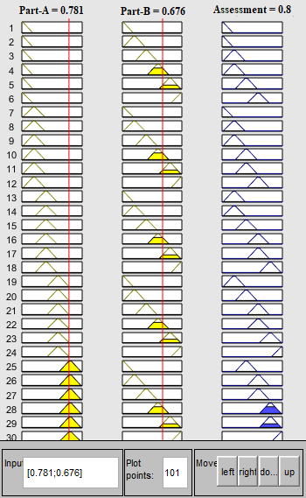
Fig. 8 Assessment Value for Exam papers Part-A and Part-B Based on Marks 82 and 71 Respectively.

Table VI: Comparing Assessment Between Existing Method and Proposed Method
SI No. | Existing Method Continuous Assessment | Proposed Method Continuous Assessment | Existing Method Exam Paper Assessment | Proposed Method Exam Paper Assessment | Existing Method Grade | Proposed Method Grade
1 | 1.00 | 0.900 | 0.729 | 0.800 | A+ | A+
2 | 0.60 | 0.858 | 0.567 | 0.606 | B+ | B+
3 | 0.50 | 0.689 | 0.538 | 0.512 | B- | B-
4 | 0.40 | 0.326 | 0.529 | 0.533 | C+ | C
5 | 0.80 | 0.338 | 0.595 | 0.627 | C+ | C+
6 | 0.00 | 0.494 | 0.676 | 0.695 | B- | B
7 | 0.60 | 0.404 | 0.548 | 0.517 | C+ | C
8 | 0.90 | 0.900 | 0.595 | 0.600 | B+ | B+
9 | 0.00 | 0.500 | 0.567 | 0.600 | C+ | B-
10 | 0.00 | 0.300 | 0.500 | 0.547 | C | C
11 | 0.00 | 0.176 | 0.662 | 0.695 | C+ | C+
12 | 1.00 | 0.763 | 0.676 | 0.645 | A- | B+
13 | 0.00 | 0.300 | 0.529 | 0.600 | C | C+
14 | 0.90 | 0.900 | 0.310 | 0.215 | C | D
15 | 0.00 | 0.151 | 0.514 | 0.505 | F | F
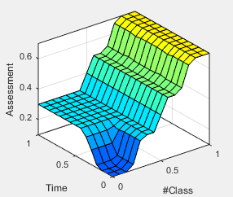

Fig. 9 Surface Viewer of Continuous Assessment.
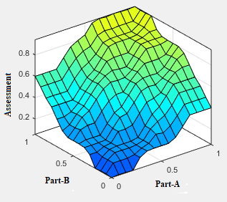

Fig. 10 Surface Viewer of Exam Papers Assessment.

Conclusion
A fair and unbiased performance evaluation system is needed for promoting education and to achieve learning outcome. Proposed method is very helpful in evaluating subjective types of answer paper. Our system considers many aspects of student’s participation, not only grades got on exam marks in a formative way. This method uses both number of class attendance by a student with time spent in class instead of only number of class attendance to evaluate his/her continuous assessment which is combined with exam paper evaluation to generate final result. Proposed system provides a smarter, fairer, transparent way to evaluate student performance. In this method for evaluating student academic performance, difference is observed between fuzzy logic-based method and the conventional method. Proposed fuzzy logic centric evaluation method has greater flexibility with associated reliability and fairness while classical method uses a fixed mathematical rule. We have compared existing method with our proposed method. The method considers the aspect such as time spent on class making it more flexible and fairer than the conventional method which is clearly presented in the comparison Table VI. The system is implemented using Fuzzy Logic Toolbox by MATLAB. However, it is need to more classroom application to be observed for obtaining more reliable statistical data. This method is tested only a course for 15 students, but it can be implemented for all the courses of all students to generate grade point average.

References
- Gokhan Gokmena, Tahir Çetin Akincib, Mehmet Tektaú, Nevzat Onatc, Gokhan Kocyigita, Necla Tektaú, “Evaluation of student performance in laboratory applications using fuzzy logic”, Procedia Social and Behavioral Sciences 2 (2010) 902–909, WCES-2010
- L.A. Zadeh, “Fuzzy sets”, Information and Control, (8), pp. 338-353, 1965.
- Echauz, J. R., & Vachtsevanos, G. J., “Fuzzy grading system. IEEE Transactionson Education”, 38(2), 158–165, 1995.
- Chiu-Keung Law, “Using fuzzy numbers in educational grading system”, Fuzzy Sets and Systems, 83(3), 311–323, 1996.
- S.M. Bai and S.M. Chen “A new method for students’ learning achievement evaluation using fuzzy membership functions”, Proceeding of the 11th Conference of Artificial Intelligence and Applications, Kaohsiung, Taiwan, Republic of China, pp. 177-184, 2006
- R. Biswas, “An application of fuzzy sets in students’ evaluation,” Fuzzy Sets System, vol. 74, 1995.
- S. M. Chen and C. H. Lee, “New methods for students’ evaluating using fuzzy set,” Proceedings of International Conference on Artificial Intelligence, 1996.
- Wilson, E., Karr, C. L., & Freeman, L. M., “Flexible, adaptive,
automatic fuzzy-based grade assigning system”, In Proceedings of the
North American fuzzy information processing society conference (pp. 334-338) 1998.
- Ramjeet Singh Yadav and Vijendra Pratap Singh, “Modeling Academic Performance Evaluation using Fuzzy C-Means Clustering Techniques”, International Journal of Computer Applications (0975 – 8887) Volume 60– No.8, December 2012.
- Arya A Surya, Merin k kurian and Surekha Mariam Varghese, “Overall Performance Evaluation of Engineering Students Using Fuzzy Logic”, International Journal on Cybernetics & Informatics (IJCI) Vol. 5, No. 2, April 2016.
- Shilpa N. Ingoley and Dr. J.W. Bakal, “Students’ Performance Evaluation Using Fuzzy Logic”, Nirma University International Conference On Engineering, Nuicone-2012, 06-08 December, 2012.
- James R. Nolan, “An expert fuzzy classification system for supporting the grading of student writing samples”, Expert Systems With Applications, Vol. 15, 1998.
- Ibrahim Saleh, Seong-in Kim “A fuzzy system forevaluating students’ learning achievement” (Expert Systems with Applications 36 (2009) 6236–6243)
- Hui-Yu Wang and Shyi-Ming Chen, “Evaluating Students’ Answer scripts Using Fuzzy Numbers Associated With Degrees of Confidence”, IEEE Transactions on Fuzzy Systems, Vol. 16, No. 2, April 2008.
- Bardul and Mohamad, “A Fuzzy Approach on Students’ Answer Scripts Criteria Based Evaluation”

